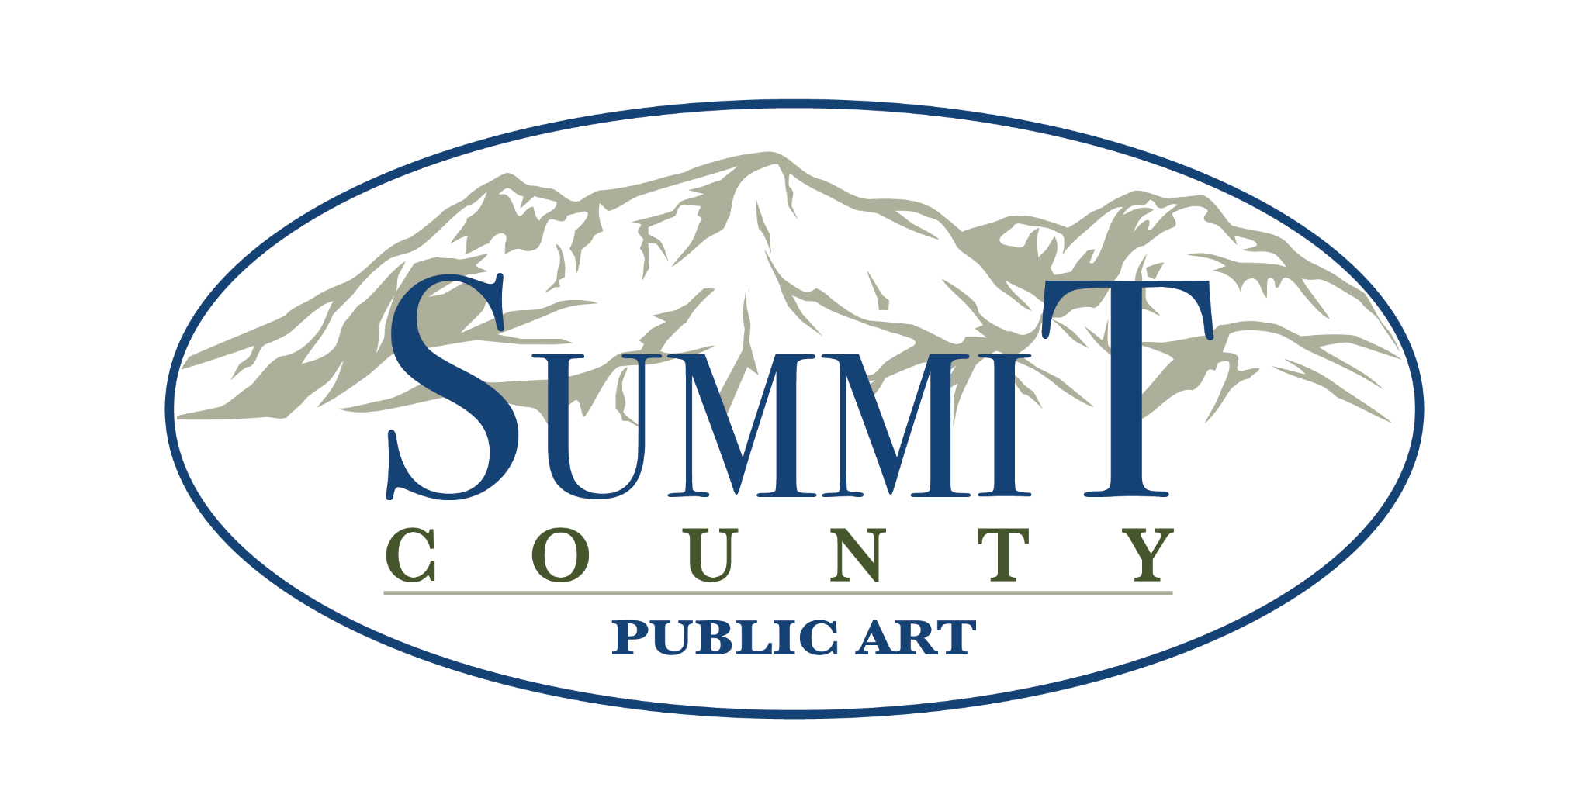
The mission of the Summit County Public Art Advisory Board is to celebrate and unite Summit County residents through public art. Program projects are aligned with County Core Areas of transportation, environmental sustainability and economic diversity.

AGENDA
SUMMIT COUNTY PUBLIC ART ADVISORY BOARD
Tuesday, July 1st 2025 at 4:00pm, Summit County Richins Building,
Room 133, 1885 W. Ute Blvd., Park City, UT 84098

The Summit County Public Art Advisory Board will also meet electronically, via Zoom, on Tuesday, July 1st, 2025 at 4:00 p.m.

Join Zoom Meeting
https://us02web.zoom.us/j/89047256358?pwd=eG5NR05hTEZtbkxieWFkVEJ2NzhxZz09

Meeting ID: 890 4725 6358
Passcode: 340926

One tap mobile
+12532050468,,89047256358#,,,,*340926# US
+12532158782,,89047256358#,,,,*340926# US (Tacoma)

Dial by your location
• +1 253 205 0468 US
• +1 253 215 8782 US (Tacoma)
• +1 346 248 7799 US (Houston)
• +1 669 444 9171 US
• +1 669 900 9128 US (San Jose)
• +1 719 359 4580 US
• +1 507 473 4847 US
• +1 564 217 2000 US
• +1 646 558 8656 US (New York)
• +1 646 931 3860 US
• +1 689 278 1000 US
• +1 301 715 8592 US (Washington DC)
• +1 305 224 1968 US
• +1 309 205 3325 US
• +1 312 626 6799 US (Chicago)
• +1 360 209 5623 US
• +1 386 347 5053 US

Meeting ID: 890 4725 6358
Passcode: 340926

Find your local number: https://us02web.zoom.us/u/kTWJaPwRI

In attendance via Zoom:
Attended in person:
Not in Attendance:
Members of the Public:
Minutes by:
The following is the agenda for said session:
1. 4:00pm CALL TO ORDER:
Called to Order by:

2. APPROVAL OF MINUTES:
June 3rd, 2025
Changes:
Approved:

3. CONFIRM ATTENDANCE/QUORUM
August 5th, 2025 SCPAAB Meeting
Attend:
Absent:

4. BOARD DISCUSSION AND ACTION ITEMS

- Washakie Shipping Update— Thea Henney (3 minutes)

- Sunrise Rotary Grant Discussion— Jocelyn Scudder (15 minutes)
$500 were awarded for Art Piano maintenance and programming
i) Discuss possible allocations for funding received
ii) Vote on a course of action, if necessary

- RAP Gateway Project Update— Thea Henney (5 minutes)

- Roundabouts Sculptures Update — Thea Henney (3 minutes)

- Select Chair and Vice Chair — Jocelyn Scudder (15 minutes)
i) Present nominees
ii) Vote on a Chair and Vice Chair to serve a 1-year term

- Farewell and Thank You to the Exiting Board Members— Thea Henney (5 minutes)

5. GENERAL BOARD BUSINESS

- Volunteer Hours — Thea Henney (3 minutes)

- Staff/ Council/ Board Communications (10 minutes)
  - Park City Public Art Advisory Board (PCPAAB) — Jocelyn Scudder (5 minutes)
  - Arts Council of Park City & Summit County Update — Jocelyn Scudder (5 minutes)
d) Budget Updates - Dan Compton/Thea Henney (5 minutes)

6. PUBLIC INPUT for any items that are not on the agenda.

7. ACTION ITEMS AND UPCOMING MEETINGS
- Confirm action items identified during meeting – Thea Henney (2 minutes)
- August 5, 2025 (4:00pm, in person at 1885 W. Ute Blvd, room 133, and via Zoom, SCPAAB monthly meeting)

Meeting Estimated to Adjourn at 5:06pm
Meeting Adjourned at:
Meeting Closed by:

2025 SCPAAB Meeting Dates
*First Tuesday of every month at 4pm, unless otherwise noted.
- August 5th, 2025
- September 2nd, 2025
- October 7th, 2025
- November 4th, 2025
- December 2nd, 2025

